Neculae Andrei-Fabian

Grupa 252

Sisteme de operare

Laboratorul 3

/sys/kern/syscalls.master

ID 331 = sys_khello

ID 332 = sys_kcp

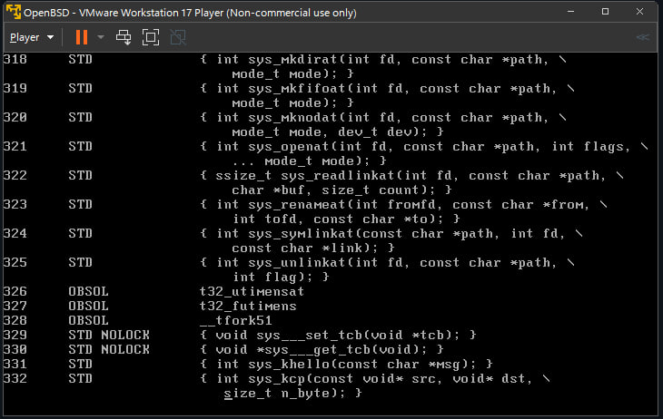

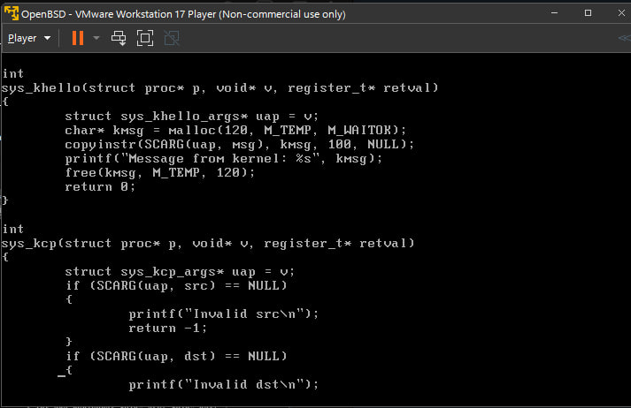/sys/kern/sys_generic.c

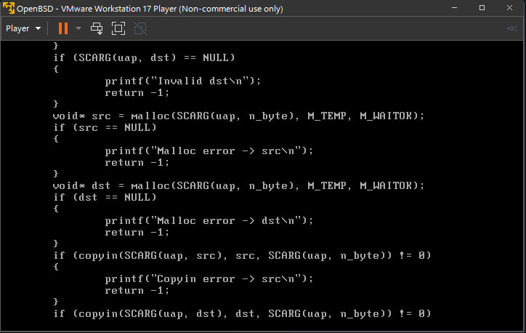

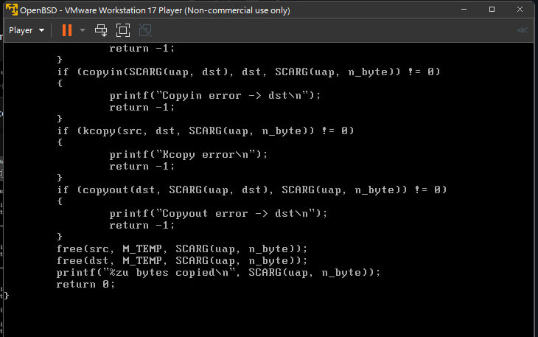

/root/file.c

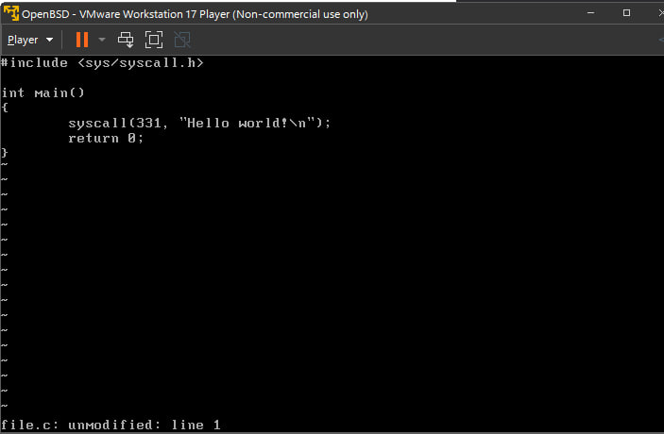

/root/kcp.c

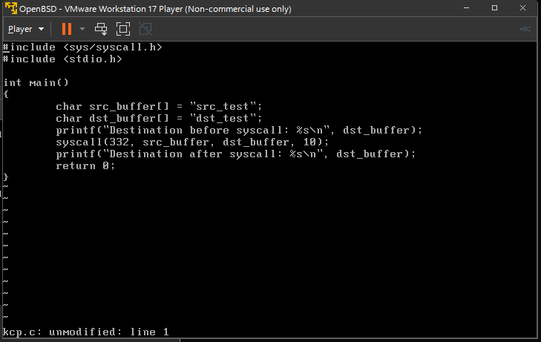

Compilari & executari

